**Pseudo Code Assignment**

**Third Year Student: Duc Nguyen – N01156279**

**First Year Student: Manpreet Parmar – N01302460**

**I. Pseudo Code – by Manpreet**

Setup

Identify address of sensor

Verify address of sensor

If verify has an error

Print to lcd (error)

End if

Log into database

If login is invalid

Prompt user to re-enter

End if

End setup

Loop

Get Temperature and save it in Temperature

Get Humidity and save it in Humidity

Send to Pi (Temperature, Humidity)

If ( 0 < Temperature <= 80 || 0 < Humidity <=80%)

Print to lcd (Temperature°c , Humidity %)

Get current time and save it in cTime

Save in data log (Temperature, Humidity, cTime)

Send log to android app (Temperature, Humidity, cTime)

Print log on android app (Temperature, Humidity, cTime)

End if

Else if

Turn the sensor off

Give user warnings

End else if

End loop

**II.UML Diagram – by Duc**

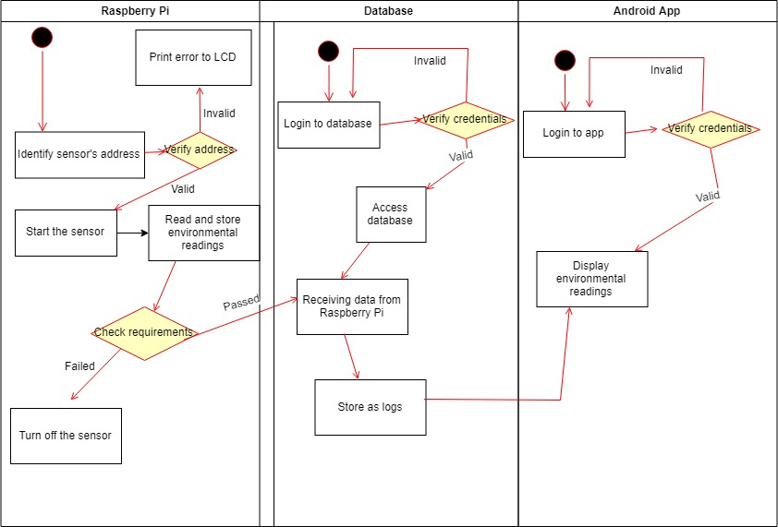

**III.Evaluation**

Manpreet’s performance was better than I expected. He replied all emails instantly, came to every meeting on time and was very communicative overall. He was eager to start the project, and delivered the product on schedule. During the discussion of the code, Manpreet demonstrated his understanding and suggestion in a very straightforward and constructive manner. He showed how critical he can think, and how potential he can be in this field, both in ethics and this particular field.

Pseudo Code grade: 4.5/5

Overall grade: 5/5